AcceptanceTesting

**UATExecution&ReportSubmission**

|  |  |
| --- | --- |
| Date | 11November 2022 |
| TeamID | PNT3022TMID24405 |
| ProjectName | Project-AI based localization and classification of skin disease with erythema |
| MaximumMarks | 4 Marks |

# PurposeofDocument

The purpose of this document is to briefly explain the test coverage and open issues of the Skindisease for Predicting our project at the time of the release to UserAcceptanceTesting (UAT).

# DefectAnalysis

Thisreportshowsthenumberofresolvedorclosedbugsateachseveritylevel,andhowtheywereresolved

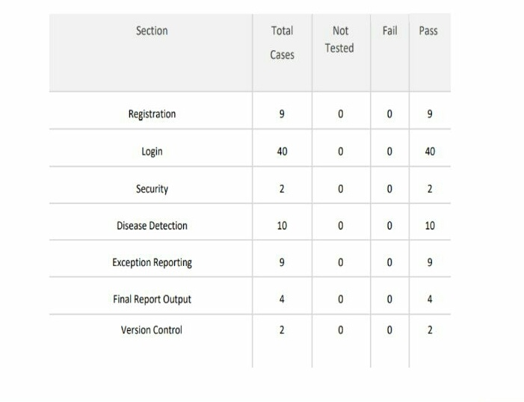

# CaseAnalysis

This reportshowsthenumberoftestcasesthathave passed,failed,anduntested

|  |  |  |  |  |
| --- | --- | --- | --- | --- |
| **Section** | **TotalCases** | **NotTested** | **Fail** | **Pass** |
| PrintEngine | 1 | 0 | 0 | 1 |
| ClientApplication | 1 | 0 | 0 | 1 |
| Security | 1 | 0 | 0 | 1 |
| OutsourceShipping | 1 | 0 | 0 | 1 |
| ExceptionReporting | 1 | 0 | 0 | 1 |
| FinalReportOutput | 1 | 0 | 0 | 1 |
| Version Control | 1 | 0 | 0 | 1 |